PIZZA SALES SQL QUERIES

1. KPI’S
2. Total Revenue:

SELECT SUM(total_price) AS Total_Revenue FROM pizza_sales

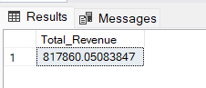

1. Average Order Value:

SELECT SUM(total_price) / COUNT(DISTINCT order_id) AS Average_Order_Value FROM pizza_sales

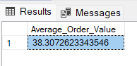

1. Total Pizza Solds

SELECT SUM(quantity) AS Total_Pizza_Sold FROM pizza_sales

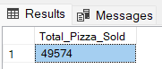

1. Total Orders

SELECT COUNT(DISTINCT order_id) AS Total_Orders FROM pizza_sales

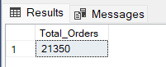

1. Average Pizza Per Order

SELECT CAST(CAST(SUM(quantity) AS DECIMAL(10,2)) / CAST(COUNT(DISTINCT order_id) AS DECIMAL(10,2)) AS DECIMAL(10,2)) AS Avg_Pizza_Per_Order FROM pizza_sales

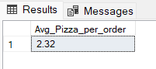

CHARTS

1. Daily Trends for Total Orders

SELECT DATENAME(DW, order_date) AS Order_day, COUNT(DISTINCT order_id) AS Total_orders

FROM pizza_sales

GROUP BY DATENAME(DW, order_date)

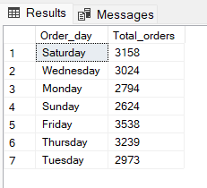

1. Monthly Trends for Total Orders

SELECT DATENAME(MONTH, order_date) AS Month_Name, COUNT(DISTINCT order_id) AS Total_Orders

FROM pizza_sales

GROUP BY DATENAME(MONTH, order_date)

ORDER BY Total_Orders DESC

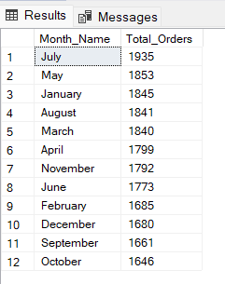

1. Percentage of sales by Pizza Category

SELECT pizza_category, SUM(total_price) * 100 / (SELECT SUM(total_price) FROM pizza_sales WHERE MONTH(order_date) = 1) AS Total_Sales

FROM pizza_sales

WHERE MONTH(order_date) = 1

GROUP BY pizza_category

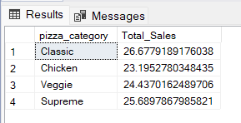

1. Percentage of sales by Pizza Size

SELECT pizza_size, CAST(SUM(total_price) AS DECIMAL(10,2)) AS Total_Sales,

CAST(SUM(total_price) * 100 / (SELECT SUM(total_price) FROM pizza_sales WHERE DATEPART(quarter, order_date) = 1) AS DECIMAL(10,2)) AS PCT

FROM pizza_sales

WHERE DATEPART(quarter, order_date) = 1

GROUP BY pizza_size

ORDER BY PCT DESC

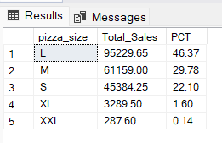

1. Top 5 pizza by revenue

SELECT TOP 5 pizza_name, SUM(total_price) AS Total_Revenue

FROM pizza_sales

GROUP BY pizza_name

ORDER BY Total_Revenue DESC

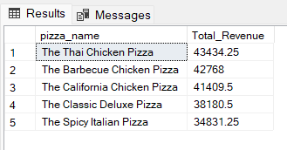

1. Bottom 5 pizza by revenue

SELECT TOP 5 pizza_name, SUM(total_price) AS Total_Revenue

FROM pizza_sales

GROUP BY pizza_name

ORDER BY Total_Revenue

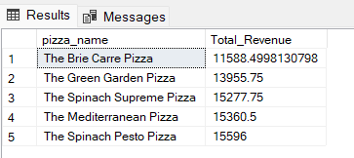

1. Top 5 pizza by quantity

SELECT TOP 5 pizza_name, SUM(quantity) AS Total_Quantity

FROM pizza_sales

GROUP BY pizza_name

ORDER BY Total_Quantity DESC

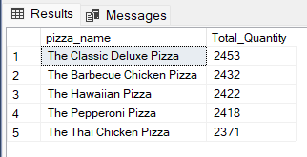

1. Bottom 5 pizza by quantity

SELECT TOP 5 pizza_name, SUM(quantity) AS Total_Quantity

FROM pizza_sales

GROUP BY pizza_name

ORDER BY Total_Quantity

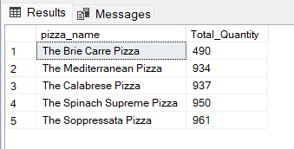

1. Top 5 pizza by order

SELECT TOP 5 pizza_name, COUNT(DISTINCT order_id) AS Total_Order

FROM pizza_sales

GROUP BY pizza_name

ORDER BY Total_Order DESC

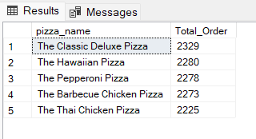

1. Bottom 5 pizza by quantity

SELECT TOP 5 pizza_name, COUNT(DISTINCT order_id) AS Total_Order

FROM pizza_sales

GROUP BY pizza_name

ORDER BY Total_Order

